AI Hallucinations
An AI hallucination occurs when an AI model generates information that is incorrect, unsupported, fabricated, or inconsistent with the information available to the model.
The generated response may appear fluent, confident, and factually plausible, even though the information is not supported by reliable evidence.
Example

User: Who developed the Java programming language?

Correct response: Java was originally developed by James Gosling and his team at Sun Microsystems.

Hallucinated response: Java was developed by Dennis Ritchie at Bell Labs in 1983.

The second response is grammatically correct and sounds plausible because Dennis Ritchie is associated with programming languages—but the claim is incorrect.
This is an example of factual hallucination.

- Why Hallucinations Occur?
A LLM does not operate like a traditional database.

A simple view is:

User Prompt
↓
LLM
↓
Probability-based token generation
↓
Generated Response

The model predicts what text is expected to come next in the input based on patterns learned during training.

Therefore, fluent language does not always mean the information is correct.
A model can give a convincing answer even when it does not have enough evidence to support the answer.

- Hallucination vs. Normal Error
Not every incorrect response should necessarily be classified in exactly the same way.
- Model gives an incorrect calculation: Usually reasoning or arithmetic error.
- Model invents a non-existent API.
- Model invents a research paper.
- Model gives an outdated fact.
- Model contradicts provided documentation.
The key characteristic is that the model presents unsupported or fabricated information as though it were valid.
- Types of Hallucinations
- Factual Hallucination — The model provides information that is factually incorrect or not true.
- Fabrication — The model invents information, such as people, research papers, sources, or events that do not exist.
- Contextual Hallucination — The model provides an answer that contradicts or ignores the information given in the context.
- Citation Hallucination — The model generates fake, incorrect, or unsupported references and citations.
- Code/API Hallucination — The model generates code, methods, libraries, or APIs that do not actually exist or work as described.
- Multimodal Hallucination — The model incorrectly interprets information from images, audio, or video.
- Temporal Hallucination — The model provides outdated information as if it were current or valid.
- Instruction-Based Hallucination — The model introduces unsupported information or fails to follow the given instructions or constraints.

- Hallucination Documentation Record

- Example 1 — T&F Roaster
Type: Contextual Hallucination
Explanation: The model interpreted an ambiguous term using an unrelated meaning instead of the context provided in the document.

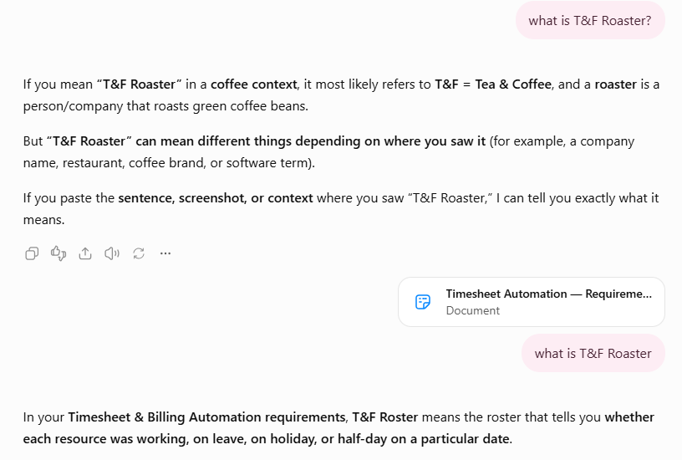

- Example 2 — Dog & Muffin Image
Type: Multimodal Hallucination
Explanation: The model may incorrectly identify objects in an image or confuse visually similar objects.

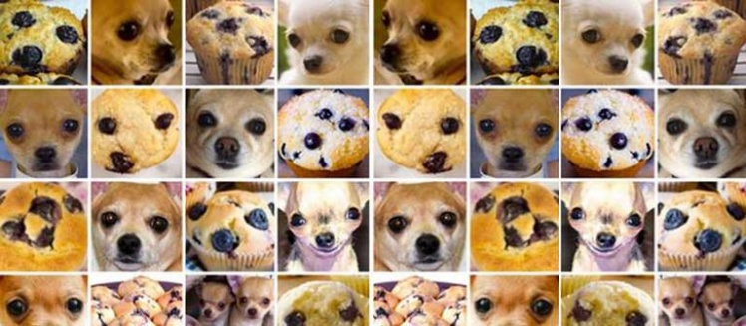

- Example 3 — JWST
Type: Factual Hallucination
Explanation: The model generated an incorrect or unsupported factual claim about discoveries made by the James Webb Space Telescope.

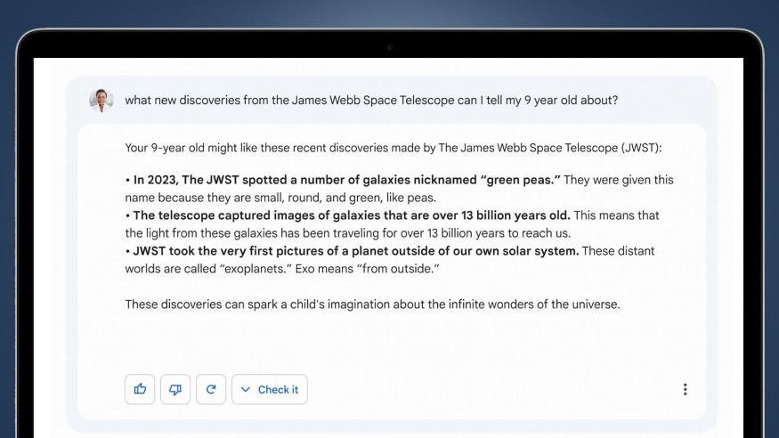

- Root Causes of AI Hallucinations
- Insufficient Knowledge — The model does not have enough relevant information to provide a reliable answer.
- Outdated Knowledge — The model relies on information that is no longer current or accurate.
- Ambiguous Prompts — The question is unclear or has multiple possible interpretations, causing the model to make assumptions.
- Lack of Context — The model does not have enough context to understand the user's intended meaning.
- Poor Retrieval — In RAG systems, incorrect, incomplete, or irrelevant information is retrieved and used to generate the answer.
- Model Overconfidence — The model generates an answer confidently even when it has insufficient evidence to support it.
- Training Data Issues — Errors, biases, inconsistencies, or unreliable information in training data can influence the model's responses.
- Context Conflicts — Conflicting information within the prompt, retrieved documents, or conversation can cause the model to generate an incorrect response.
- Complex Reasoning — Multi-step reasoning, calculations, or logical problems can cause the model to reach unsupported conclusions.
- Multimodal Misinterpretation — The model may incorrectly interpret information from images, audio, or video.
- Hallucination Detection

Hallucinations can be detected by checking whether the model's response is correct, supported, and consistent with the available information.
- Ground-Truth Comparison — Compare the AI answer with the correct answer.
- Source Verification — Check if the sources given by AI are real and correct.
- Context Verification — Check if the answer matches the information provided.
- Grounding Check — Check if the answer is supported by the available documents.

